**Software Engineering Lab Experiment No. 7**

**Aim:** Perform Functional testing for the project

**Objectives:**

1. The primary objective of functional testing for login and account transactions is to ensure that these critical components of the Spring Boot bank application perform as intended.
2. This includes validating the accuracy and security of the login process and verifying the correctness of account transactions such as fund transfers, balance inquiries, and transaction history.

**Requirements:**

1. Computer with internet access.
2. Sample software project or problem statement for requirements analysis.
3. Word processing software for creating the lab report.

**Concept:**

* Functional testing involves assessing the application's functionalities by testing its inputs, outputs, and the interaction of its components. For login and account transactions, this means evaluating the user interface, data processing, security features, and the overall user experience.

**Tools:**

1. **Postman**: Useful for API testing, especially for account transactions that may involve backend APIs.

**Steps:**

1.Writing down test cases in excel sheet

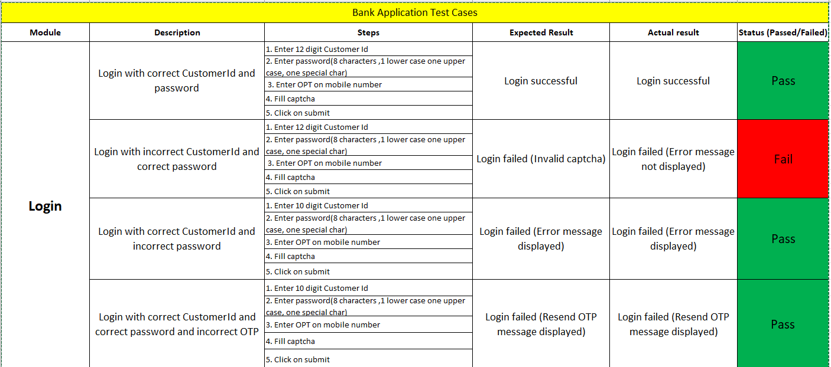

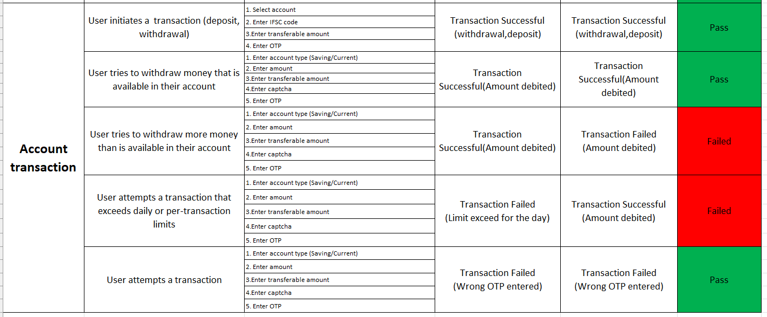

2. User tries to withdraw money that is available in their account (Transaction failed but money debited

-Login Page

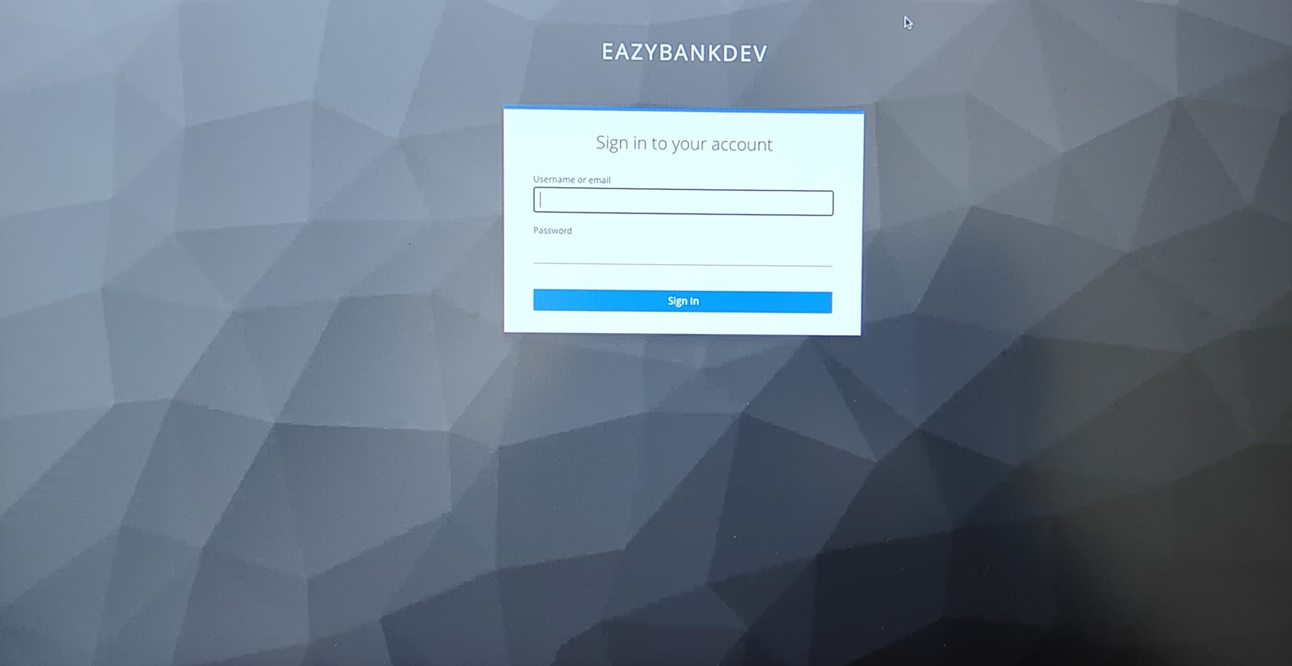

- Welcome, Page after successful login.

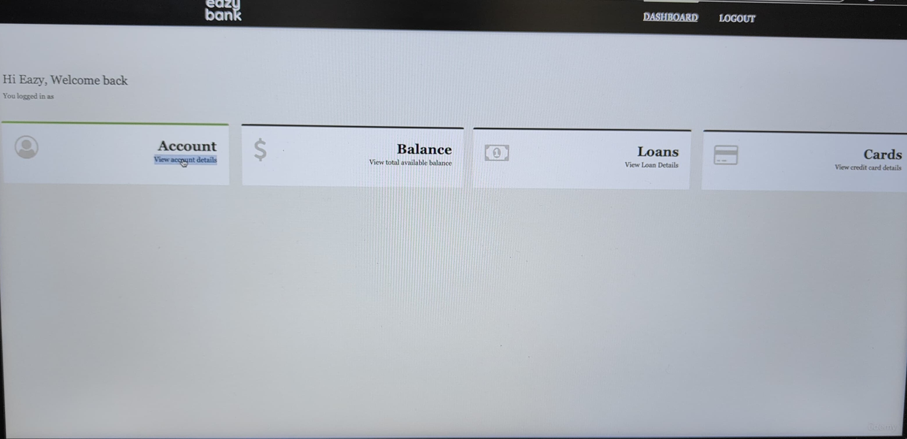

-Account Transaction Section

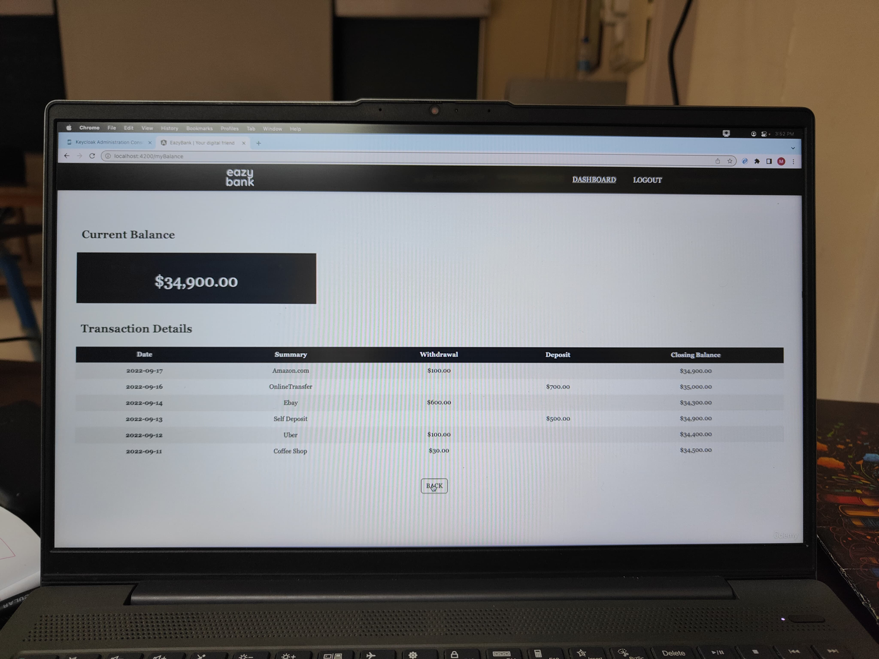

**Conclusion:**

We learnt that, Functional testing for login and account transactions is crucial to ensure the reliability, security, and user-friendliness of these core functionalities. By systematically testing each component, automating repetitive tasks, and validating the security measures in place, the testing process aims to enhance the overall quality of the Spring Boot bank application.

**References:**

- <https://www.softwaretestinghelp.com/black-box-testing/>

- https://birdeatsbug.com/blog/black-box-testing